**SKILLSCHOLAR**

**Minor Project-II**

**(ENSI252)**

*Submitted in partial fulfilment of the requirement of the degree of*

**BACHELOR OF TECHNOLOGY**

*to*

**K.R Mangalam University**

*by*

**Vikrant Singh 2301010028**

**Subham Sinha 2301010013**

Under the supervision of

**Internal Supervisor External Supervisor**

**Dr. Meenu Vijarania Mr. Parth Kotecha**

**Associate Professor Senior Software Engineer**

**KRMU Walmart Global Tech**



Department of Computer Science and Engineering

School of Engineering and Technology

K.R Mangalam University, Gurugram- 122001, India

April 2025

**CERTIFICATE**

This is to certify that the Project Synopsis entitled, “**SKILLSCHOLAR**” submitted by “**Vikrant Singh (2301010028) and Shubham Sinha (2301010013)”** to **K.R Mangalam University, Gurugram, India,** is a record of bonafide project work carried out by them under my supervision and guidance and is worthy of consideration for the partial fulfilment of the degree of **Bachelor of Technology** in **Computer Science and Engineering** of the University.

**Type of Project**

**Industry Based**

Signature of Internal supervisor

Dr. Meenu Vijarania Associate Professor KRMU

Signature of Project Coordinator

Date: 28th April 2025

**INDEX**

|  |  |  |
| --- | --- | --- |
|  | Abstract | Page No. |
|  | Introduction (description of broad topic) |  |
|  | Motivation |  |
|  | Literature Review/Comparative work evaluation |  |
|  | Gap Analysis |  |
|  | Problem Statement |  |
|  | Objectives |  |
|  | Tools/platform Used |  |
|  | Methodology |  |
|  | Experimental Setup |  |
|  | Evaluation Metrics |  |
|  | Results And Discussion |  |
|  | Conclusion & Future Work |  |
|  | References |  |

**ABSTRACT**

Access to quality education is a fundamental right, but financial barriers often prevent talented students from pursuing higher education. Scholarships serve as a vital tool in bridging this gap, yet students frequently face challenges such as scattered and outdated information, complex eligibility criteria, tedious application processes, and inefficient scholarship discovery methods. Many existing platforms fail to address these issues due to fragmented data, lack of personalization, and poor user experience.

To solve this problem, SkillScholar is introduced as an scholarship discovery platform that connects students with the best scholarship opportunities based on their academic achievements. It is a user-friendly, and comprehensive scholarship aggregation platform. It provides students with real-time, merit-based, need-based, category-specific, and research-oriented scholarship listings, enabling them to find relevant opportunities efficiently. Unlike traditional platforms, SkillScholar offers an automated, data-driven approach that simplifies scholarship discovery, enhances accessibility, and increases transparency.

***KEYWORDS: Scholarships, eligibility, transparency, fragmented data***

**Chapter 1**

**Introduction**

1. **Background of the project**

Education is a powerful tool for social and economic development, enabling individuals to achieve personal growth and contribute to society. However, financial constraints remain a significant barrier for many students worldwide. While scholarships provide a solution by offering financial aid based on merit, need, or other criteria, students often struggle with the lack of centralized information, confusing eligibility criteria, and inefficient application processes.

Many students, particularly those from underprivileged backgrounds, are either unaware of available scholarships or miss deadlines due to the absence of a structured scholarship discovery system. Existing platforms provide some level of scholarship information, but they often lack updated listings, intuitive user interfaces, or personalized recommendations.

To address these challenges, SkillScholar is introduced as a one-stop platform for students to access verified scholarships, filter opportunities based on their profiles, and receive guidance throughout the application process. The platform leverages matching algorithms, a centralized database, and a user-friendly dashboard to enhance accessibility and efficiency.

## Importance of Scholarships

Scholarships play a crucial role in ensuring equal access to education by:

* Reducing financial burdens on students and families.
* Encouraging academic excellence by rewarding merit-based achievements.
* Promoting diversity and inclusion by supporting students from different social, economic, and cultural backgrounds.
* Facilitating research and innovation by funding specialized study programs.

Despite the availability of numerous scholarships, many go unclaimed each year due to lack of awareness and complex application processes. SkillScholar seeks to bridge this gap by streamlining the scholarship search and application experience.

## Need for a Centralized Platform

A well-structured, AI-powered, and automated scholarship management system is essential to:

* Eliminate information silos by integrating various scholarship opportunities into a single platform.
* Reduce the time spent on searching by providing customized recommendations.
* Simplify the application process with guided assistance and document management.
* Enhance transparency in scholarship awarding mechanisms.

SkillScholar will serve as a reliable and accessible digital solution that helps students maximize their educational opportunities while minimizing financial stress.

Table 1. Existing systems

| **Factors** | **Evaluation Criteria** | **System A** scholarships.com | **System B** Fastweb | **System C** Buddy4Study |
| --- | --- | --- | --- | --- |
| **Scholarship Database** | - Size of listed Scholarships | Large Over (3.7 M) | Large (Over 1.5M) | Medium (Focused on India) |
| **Search & Filters** | - Availability of detailed search filters | Basic | Moderate | |  | | --- | | Extensive (eligibility, amount, etc.) |  |  | | --- | |  | |
| **Personalization** | |  | | --- | | - Personalized recommendations |  |  | | --- | |  | | Limited | Good | Good |
| |  | | --- | | **User Experience (UX/UI)** |  |  | | --- | |  | | |  | | --- | | - Website/app ease of use |  |  | | --- | |  | | Moderate | Good | Very Good |
| |  | | --- | | **Scholarship Alerts** |  |  | | --- | |  | | |  |  |  |  |  | | --- | --- | --- | --- | --- | | |  |  |  | | --- | --- | --- | | |  | | --- | | - Email/Push alerts for new scholarships |  |  | | --- | |  | |  |  | | --- | |  | |  |  | | --- | |  | | Yes | Yes | Yes |
| |  |  |  | | --- | --- | --- | | |  | | --- | | **Application Assistance** |  |  | | --- | |  | |  |  | | --- | |  | | |  |  |  |  |  | | --- | --- | --- | --- | --- | | |  |  |  | | --- | --- | --- | | |  | | --- | | - Direct application support |  |  | | --- | |  | |  |  | | --- | |  | |  |  | | --- | |  | | No | No | Yes (in some cases) |
| |  | | --- | | **Verification & Credibility** |  |  | | --- | |  | | |  | | --- | | - Authenticity checks of scholarships |  |  | | --- | |  | | Basic | Basic | |  | | --- | | Verified listings |  |  | | --- | |  | |
| |  | | --- | | **Mobile Accessibility** |  |  | | --- | |  | | |  | | --- | | - Mobile app or mobile-friendly web |  |  | | --- | |  | | |  | | --- | | No App |  |  | | --- | |  | | |  | | --- | | App Available |  |  | | --- | |  | | |  | | --- | | App Available |  |  | | --- | |  | |
| |  | | --- | | **Integration & Partnerships** |  |  | | --- | |  | | |  | | --- | | - Partnerships with universities, NGOs |  |  | | --- | |  | | Limited | Moderate | Moderate |
| **Scalability** | |  | | --- | | - Adding new categories/scholarships easily |  |  | | --- | |  | | Scalable | Scalable | High Scalable |
| |  | | --- | | **Data Privacy & Security** |  |  | | --- | |  | | |  |  |  | | --- | --- | --- | | |  | | --- | | - User data protection policies |  |  | | --- | |  | |  |  | | --- | |  | | Standard | Standard | Strong Compliance |
| |  | | --- | | **Cost to Users** |  |  | | --- | |  | | |  | | --- | | - Charges for students |  |  | | --- | |  | | Free | Free | Free |
| |  | | --- | | **Revenue Model** |  |  | | --- | |  | | |  | | --- | | - How platform earns |  |  | | --- | |  | | |  | | --- | | Ads, Affiliations |  |  | | --- | |  | | |  | | --- | | Ads, Affiliations |  |  | | --- | |  | | |  | | --- | | Partnerships, Ads |  |  | | --- | |  | |
| |  | | --- | | **Support Services** |  |  | | --- | |  | | |  | | --- | | Customer Support / Helpdesk |  |  | | --- | |  | | Limited | Limited | Moderate |
| |  | | --- | | **Community Engagement** |  |  | | --- | |  | | |  | | --- | | Forums, reviews, peer support |  |  | | --- | |  | | No | No | Limited |

1. **MOTIVATION**

The development of SkillScholar is driven by multiple factors, including personal, academic, and societal challenges associated with scholarship accessibility.

## Challenges Faced by Students

Many students, especially those from lower-income backgrounds, encounter several difficulties in securing scholarships, such as:

* Lack of Awareness: Most students are unaware of available scholarships due to the absence of a centralized information hub.
* Complex Eligibility Criteria: Many scholarships have detailed criteria that are difficult to understand, leading to confusion and missed opportunities.
* Tedious Application Processes: The requirement of multiple forms, essays, and supporting documents creates a time-consuming and repetitive application experience.
* Outdated or Incorrect Information: Many existing platforms provide incomplete or outdated scholarship listings, making it difficult for students to find accurate details.

## The Need for an AI-Powered Scholarship Platform

To address these challenges, SkillScholar is designed to:

* Use AI and machine learning to match students with relevant scholarships based on academic achievements, financial status, and extracurricular activities.
* Automate document submission and tracking, reducing the complexity of application management.
* Provide real-time updates on new and expiring scholarships to keep students informed.
* Create a structured database that ensures verified and up-to-date scholarship listings.

## Addressing the Gap in Existing Platforms

While several scholarship platforms exist, they often lack:

* Personalization: They provide generic lists instead of tailored recommendations.
* Comprehensive database management: Many platforms have incomplete or unverified listings.
* Interactive user experience: Poor UI/UX design makes it difficult for students to navigate.

SkillScholar aims to provide a more advanced, user-friendly, and data-driven approach to help students find and apply for scholarships efficiently and transparently.

**Chapter 2**

**LITERATURE REVIEW**

The **literature review** examines existing scholarship platforms, their strengths and weaknesses, and the technological advancements that can improve the scholarship discovery process.

## **4.1 Existing Scholarship Platforms: Strengths and Weaknesses**

Several platforms provide scholarship information, but they come with **limitations** that hinder efficiency.

### **Strengths of Existing Platforms**

* **Centralized scholarship listings** for easier access.
* **Search filters** for country, field of study, and eligibility criteria.
* **Basic notifications** for deadline reminders.

### **Weaknesses of Existing Platforms**

* **Lack of real-time updates**, leading to expired or irrelevant scholarship listings.
* **Complex navigation** due to cluttered interfaces.
* **Inconsistent eligibility matching**, making it difficult for students to find the right opportunities.
* **Lack of application tracking**, forcing students to manually follow up on their submissions.

## **4.2 Technological Innovations in Scholarship Management**

To improve the **scholarship discovery and application process**, SkillScholar integrates several **advanced technologies**:

### **Artificial Intelligence (AI) & Machine Learning (ML)**

* **Personalized scholarship recommendations** based on student profiles.
* **Automated eligibility checks** to match students with relevant opportunities.
* **Predictive analytics** to suggest scholarship success probabilities.

### **Blockchain for Transparency**

* **Secure verification of application documents** to prevent fraud.
* **Smart contracts** for automating scholarship disbursement.

### **Cloud-Based Data Management**

* **Real-time scholarship database** with **automatic updates**.
* **Easy access to applications and supporting documents**.

## **4.3 Need for an Improved Scholarship Platform**

Based on the **literature review**, SkillScholar addresses critical gaps in existing systems by:

* **Providing AI-powered scholarship matching** for personalized recommendations.
* **Ensuring transparency and security** through blockchain integration.
* **Streamlining applications** with automated tracking and document verification.

# GAP ANALYSIS

## **5.1 Introduction to Gap Analysis**

A gap analysis helps identify **the shortcomings of existing scholarship platforms** and highlights areas for improvement. By evaluating the differences between **current systems** and the **ideal scholarship management system**, we can better understand how SkillScholar can fill these gaps.

## **5.2 Identified Gaps in Existing Scholarship Platforms**

Several existing scholarship platforms offer access to financial aid opportunities, but they suffer from significant **limitations**, such as:

### **1. Lack of a Centralized and Updated Database**

* Many platforms provide **incomplete or outdated** scholarship information.
* Students often struggle to find **relevant scholarships** due to **scattered and unverified listings**.

### **2. Inefficient Search and Filtering Mechanisms**

* Most platforms offer **basic search filters** but fail to provide **AI-driven recommendations** tailored to individual profiles.
* **Keyword-based searches** often return irrelevant results, making it difficult to find suitable scholarships.

### **3. Absence of Personalized Scholarship Matching**

* Current systems do not use **machine learning algorithms** to analyze a student’s academic profile and suggest the most relevant scholarships.
* Students waste time applying for scholarships they are **not eligible for** due to the **lack of intelligent matching**.

### **4. Limited Application Tracking and Management**

* Once students apply for scholarships, they often have **no way to track** the status of their applications.
* Scholarship platforms lack **integrated dashboards** that help students manage multiple applications efficiently.

### **5. Poor User Experience and Accessibility Issues**

* Many platforms suffer from **cluttered interfaces, slow response times, and difficult navigation**.
* Lack of **mobile-friendly** platforms prevents students from applying on-the-go.

Here’s the **bar chart** showing the key barriers students face in accessing scholarships. 🎓📊

* **Lack of Awareness (45%)** and **Financial Constraints (50%)** are the biggest obstacles.
* **Complex Application Processes (30%)** also discourage many students.

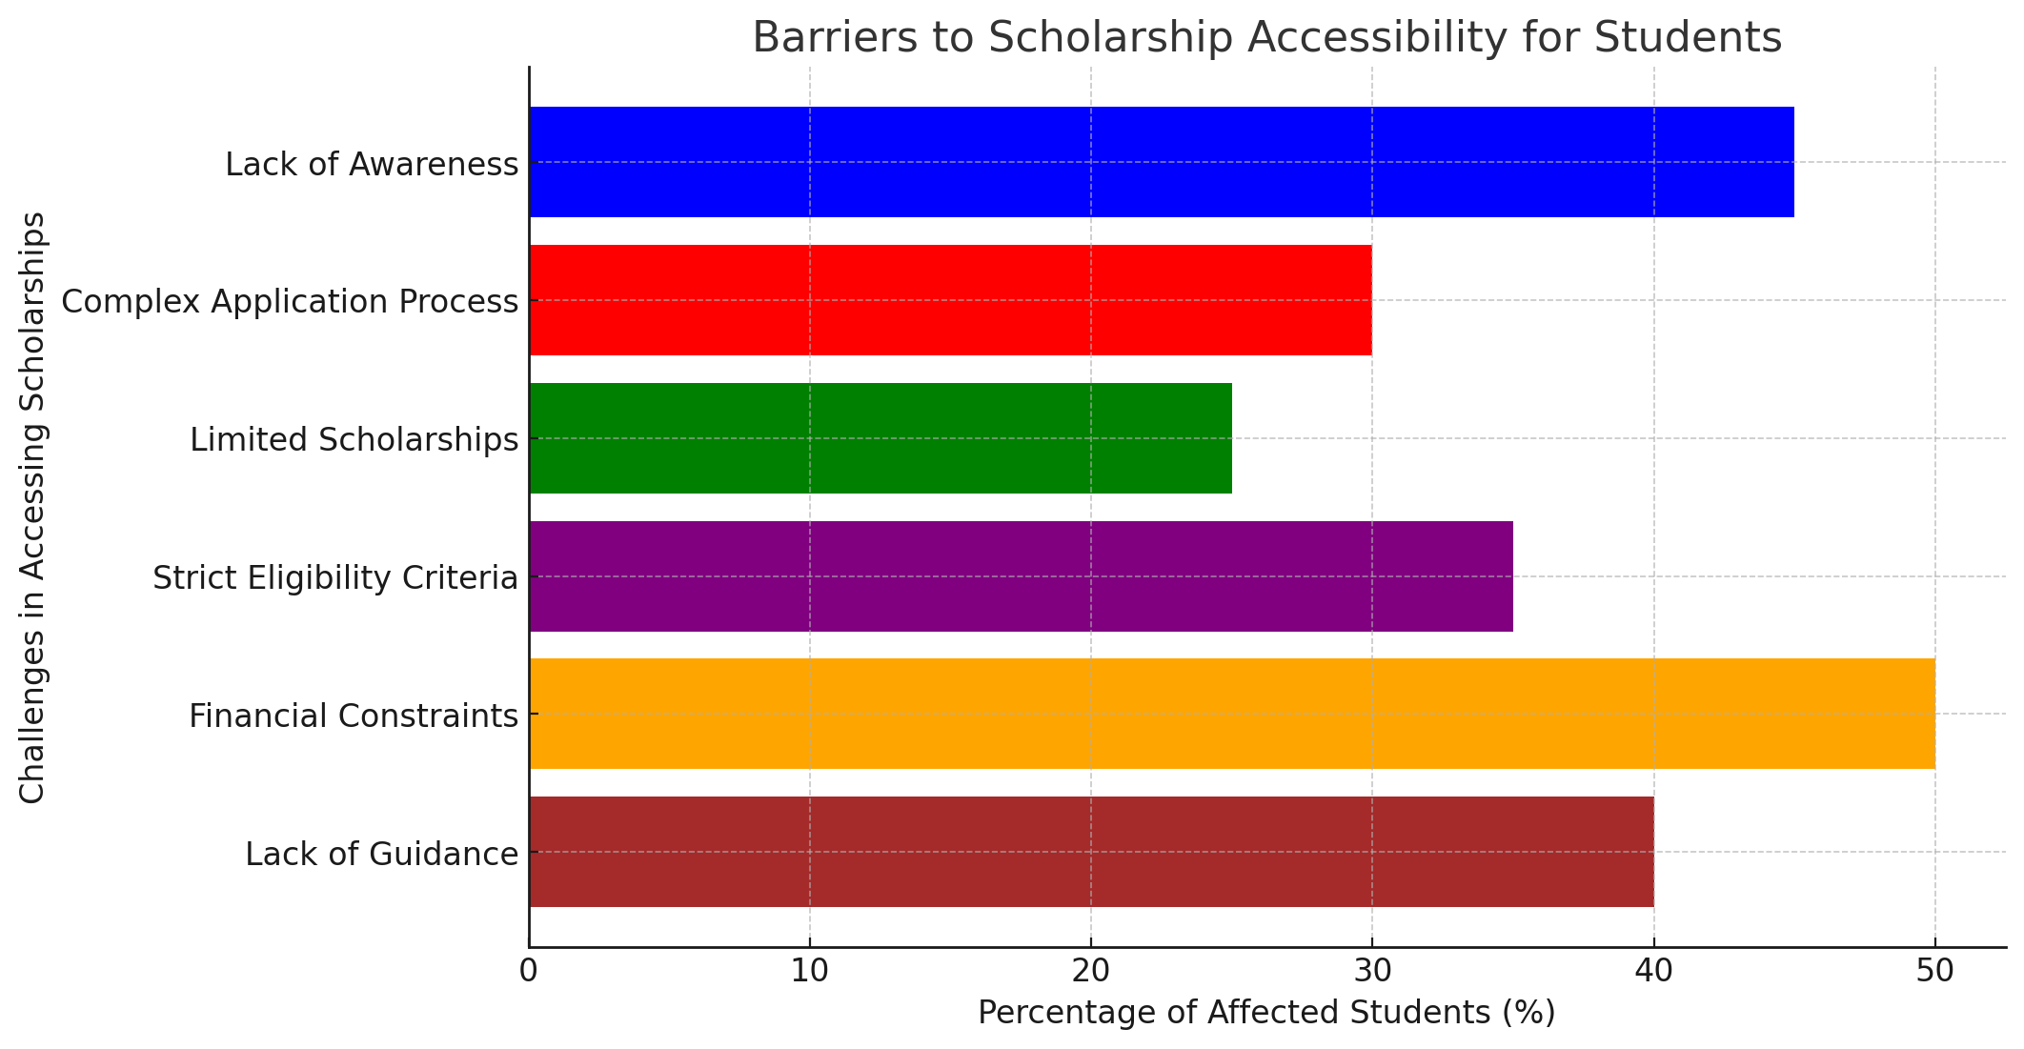

## **5.3 Bridging the Gap with SkillScholar**

SkillScholar is designed to **eliminate these inefficiencies** through:

* **A centralized and real-time updated database** with accurate scholarship listings.
* **AI-powered matching algorithms** that provide personalized recommendations.
* **An intuitive and user-friendly dashboard** for application tracking and document management.
* **Automated eligibility checks** to ensure students apply for the right opportunities.
* **Blockchain-based document verification** to ensure transparency and security.

By addressing these key gaps, SkillScholar aims to **revolutionize the scholarship application process and improve accessibility for students worldwide**.

# **Problem Statement**

## **6.1 Defining the Problem**

Despite the availability of numerous scholarships, many students **fail to access financial aid due to lack of information, complex eligibility requirements, and inefficient search mechanisms**. Existing platforms are **fragmented, outdated, and non-personalized**, making it challenging for students to find and apply for the right scholarships.

## **6.2 Core Challenges**

The main issues that students face include:

1. **Lack of Awareness** – Many students **do not know about available scholarships** or struggle to find verified sources.
2. **Confusing Application Processes** – Multiple forms, document submissions, and eligibility requirements create **a frustrating experience**.
3. **Limited Access for Underprivileged Students** – Many platforms **do not cater to students from disadvantaged backgrounds**, leading to missed opportunities.
4. **No Personalization** – Scholarship platforms do not provide **tailored recommendations** based on students’ profiles, leading to **wasted time and effort**.

## **6.3 Proposed Solution: SkillScholar**

To overcome these challenges, SkillScholar will:

* **Offer a centralized platform** that aggregates scholarships from multiple sources.
* **Provide AI-driven recommendations** to match students with the best opportunities.
* **Automate application tracking and notifications** to ensure students never miss deadlines.
* **Integrate a seamless user experience** for quick and efficient scholarship searches.

By addressing these challenges, SkillScholar will **make scholarships more accessible, transparent, and user-friendly**.

# **OBJECTIVES**

## **7.1 Primary Objectives**

SkillScholar aims to **redefine scholarship accessibility** by achieving the following:

### **1. Create a Comprehensive and Centralized Scholarship Database**

* Aggregate verified scholarships from multiple sources.
* Ensure **real-time updates** and removal of outdated listings.

### **2. Develop an AI-Powered Matching System**

* Analyze student profiles to **suggest personalized scholarships**.
* Automate **eligibility checks** to ensure relevant applications.

### **3. Simplify the Application Process**

* Provide **one-click applications** for selected scholarships.
* Automate **document submission and verification** to reduce paperwork.

### **4. Enhance Transparency and Accessibility**

* Use **blockchain technology** to secure student data and application records.
* Develop a **mobile-friendly platform** to increase accessibility.

### **5. Introduce Application Tracking and Notifications**

* Provide a **dashboard for students to track application progress**.
* Send **real-time alerts** about deadlines and new scholarships.

## **7.2 Long-Term Goals**

* Expand SkillScholar to **support international scholarships**.
* Partner with educational institutions and organizations to **increase funding opportunities**.
* Integrate **multi-language support** to reach a global audience.

By achieving these objectives, SkillScholar will serve as a **one-stop solution** for students seeking financial aid, **revolutionizing the scholarship application process worldwide**.

# Tools/Technologies Used

## **8.1 Technologies and Platforms Used in SkillScholar**

To build an efficient, user-friendly, and scalable **scholarship management system**, we use a combination of **frontend, backend, database, and AI-driven technologies**.

| **Component** | **Technology/Platform Used** | **Purpose** |
| --- | --- | --- |
| **Frontend (UI/UX)** | React.js, Tailwind CSS, Bootstrap | Develop an intuitive and responsive user interface |
| **Backend** | Node.js, Express.js | Handle user requests and manage API endpoints |
| **Database** | MongoDB (NoSQL) or MySQL (Relational DB) | Store scholarship details, user profiles, and application history |
| **AI & Machine Learning** | TensorFlow, Scikit-learn | Implement personalized scholarship recommendation algorithms |
| **Blockchain Integration** | Hyperledger Fabric, Ethereum Smart Contracts | Ensure transparency in document verification |
| **Cloud Storage** | AWS S3, Firebase | Store user documents securely |
| **Version Control & Deployment** | GitHub, Docker, Kubernetes | Enable collaboration and smooth deployment |
| **Notification Services** | Firebase Cloud Messaging (FCM), Twilio | Send real-time scholarship updates & deadline reminders |

## **8.2 Why These Technologies?**

* **React.js & Tailwind CSS**: Ensure a **modern, responsive, and smooth UI/UX** for students.
* **Node.js & Express.js**: Provide a **scalable backend** that efficiently handles multiple user requests.
* **MongoDB/MySQL**: **Optimized storage** of scholarships and user data.
* **AI-driven Matching**: Helps match students with the **most relevant** scholarships based on their profiles.
* **Blockchain for Security**: **Prevents fraud** and ensures transparency in document verification.
* **Cloud-based Hosting**: **Scalable and cost-efficient** storage solutions.

By leveraging these technologies, SkillScholar provides a **fast, secure, and user-friendly** platform for students seeking scholarships.

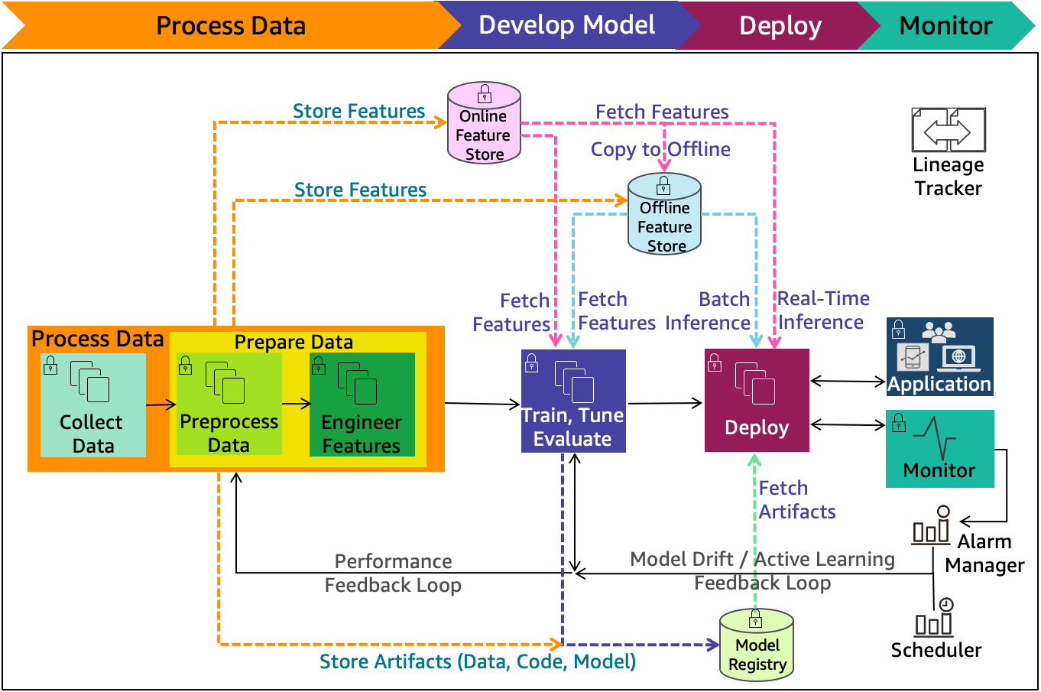

Figure 1. Figure Description

# **METHODOLOGY**

The development of SkillScholar follows a structured methodology to ensure **efficiency, scalability, and user satisfaction**.

## **9.1 System Flowchart**

The following flowchart illustrates the **overall process of SkillScholar**, from student registration to scholarship application.

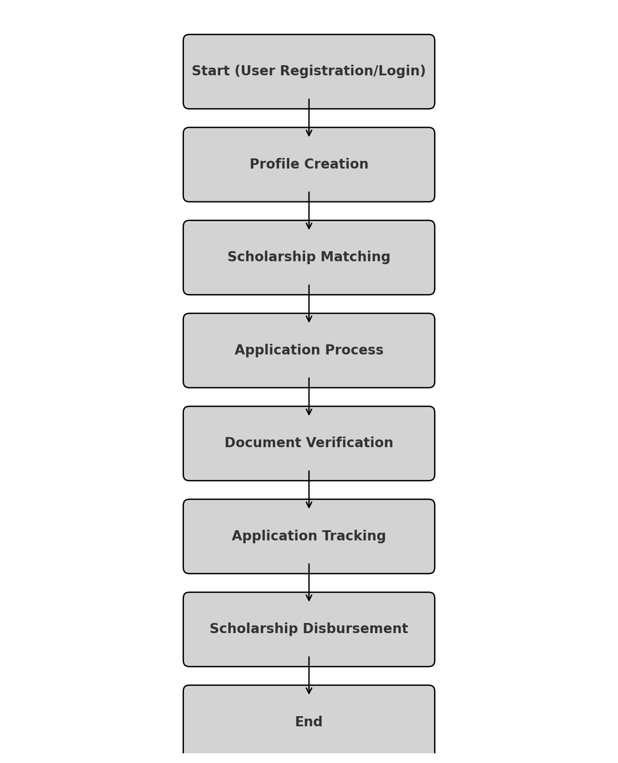

1. **User Registration/Login** → Student creates an account or logs in.
2. **Profile Creation** → User enters academic details, financial status, and preferences.
3. **Scholarship Matching** → AI-based recommendation system suggests suitable scholarships.
4. **Application Process** → User applies for selected scholarships.
5. **Document Verification** → Blockchain secures documents and verifies authenticity.
6. **Application Tracking** → Students track progress and receive updates.
7. **Scholarship Disbursement** → Approved students receive funding.

[ Start ]

↓

[ Student Registers/Login ]

↓

[ Enter Academic & Financial Details ]

↓

[ AI Algorithm Matches Scholarships ] → [ Database of Verified Scholarships ]

↓

[ Student Receives Personalized Recommendations ]

↓

[ Application Submission & Tracking ]

↓

[ End ]

**9.2** **Requirement Gathering:**

* Collect requirements from stakeholders (students, educational institutions, scholarship providers).
* Identify key features of the platform, including scholarship listings, filtering by eligibility criteria, and user registration.

9.3 **System Design:**

* Design the database schema to store user information, scholarship details, and application statuses.
* Create wireframes or prototypes for the SkillScholar interface (UI/UX design).
* Define the functionalities of the platform (search, application process, tracking status).

9.4 **Database Development:**

* Develop the database structure based on the ER diagram. This includes tables for users, scholarships, applications, and reviews.
* Set up relationships (one-to-many, many-to-many) to connect the various entities, such as students applying for multiple scholarships.

9.5 **Platform Development:**

* Build the front-end of the platform with a user-friendly interface that allows easy navigation through scholarships and application forms.
* Develop the back-end to handle the application process, including user authentication and data management.

**9.6 Testing:**

* Perform unit testing to check individual components for functionality.
* Conduct integration testing to ensure the front-end and back-end work together seamlessly.
* Test with real data to simulate actual user experiences and identify any bugs or issues.

**9.7 Deployment:**

* Deploy the platform on a web server or cloud platform, ensuring it is scalable to handle multiple users simultaneously.
* Ensure security features are in place (e.g., encryption, secure login).

**9.8 Maintenance:**

* Monitor the platform for any issues or feedback from users.
* Regularly update the platform to fix bugs, add new features, and keep the system secure.

# **REFERENCES**

1. **Websites:**

* Author or Organization. (Year). Title of the Webpage. Retrieved from URL.
* Example:
  + National Scholarship Portal. (2024). List of Government Scholarships in India. Retrieved from <https://www.scholarships.gov.in>

1. **Online Articles or Blogs:**
   1. Author(s). (Year, Month Day). Title of the Article. Website Name. URL.
   2. Example:
      1. Parker, M. (2023, January 15).

"How Scholarship Platforms are Transforming Education." EdTech Blog. [https://www.edtechblog.com/scholarship-platforms](Online%20Articles%20or%20Blogs:%20%20Author(s).%20(Year,%20Month%20Day).%20Title%20of%20the%20Article.%20Website%20Name.%20URL.%20Example:%20Parker,%20M.%20(2023,%20January%2015).%20%22How%20Scholarship%20Platforms%20are%20Transforming%20Education.%22%20EdTech%20Blog.%20https:/www.edtechblog.com/scholarship-platforms%20)